Real time

Question 1

Comment on the importance of the resolution:

It is possible to schedule events to the nearest nanosecond. This allows us to make a decision every nanosecond. We have more time resolution in the timeslots. It can respond to an interrupt to the nearest nanosecond.

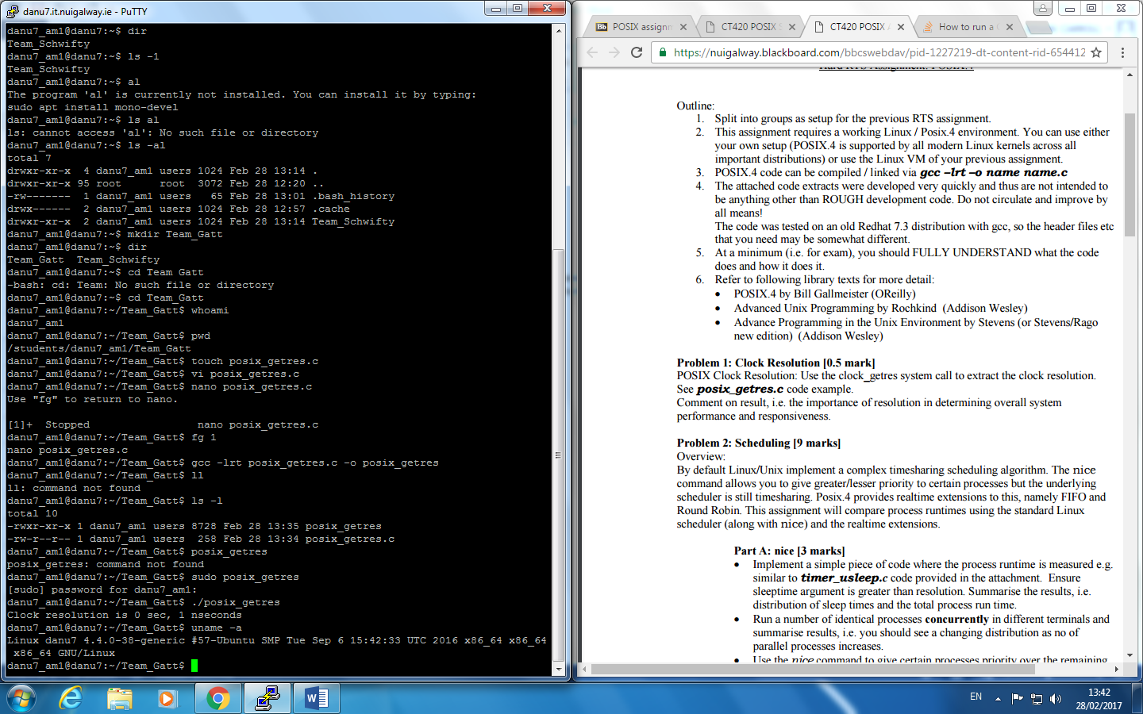

Question2